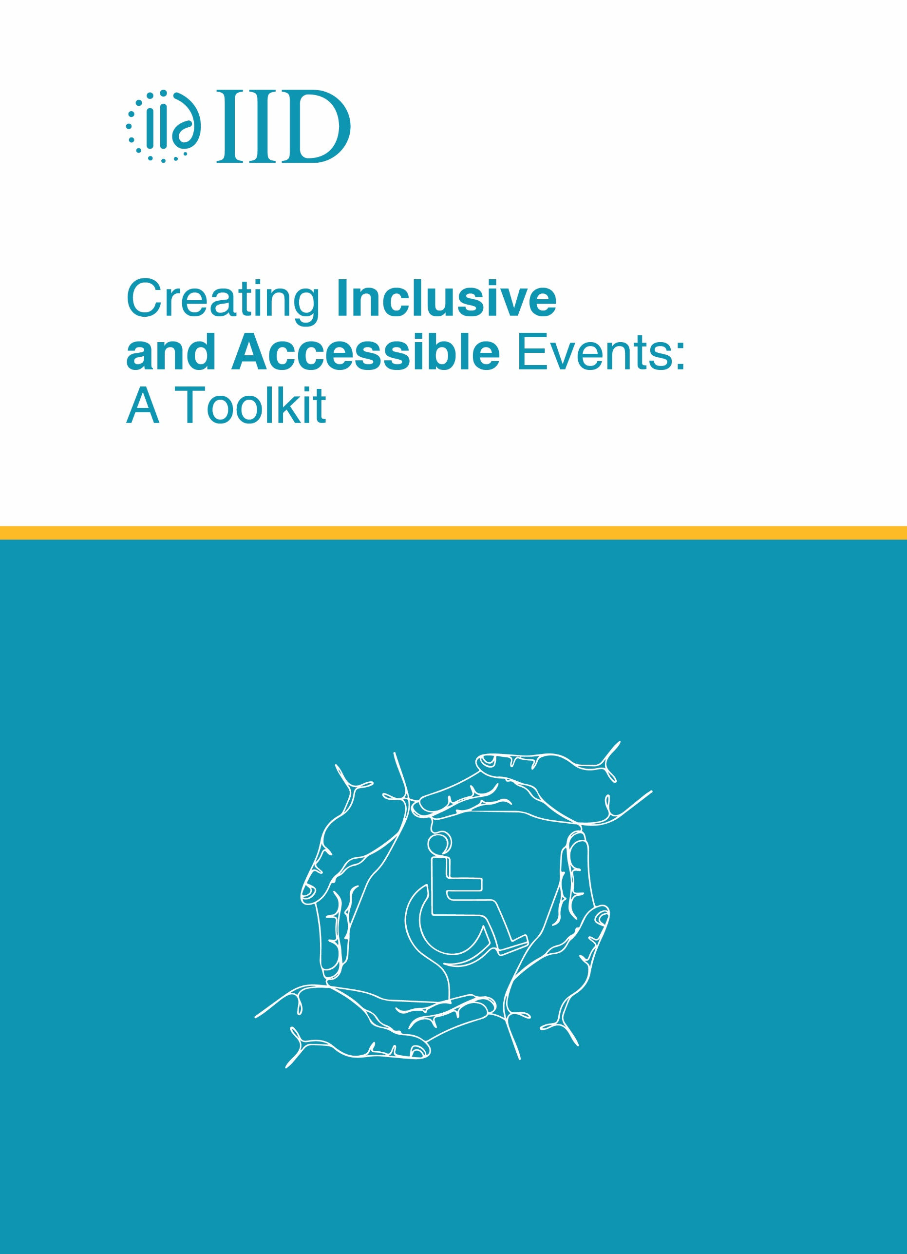

Creating Inclusive and Accessible Events: A Toolkit

© 2023 Institute of Informatics and Development (IID)
All rights reserved.

This toolkit is a living document that will be updated and revised as it is used to support IID’s work on accessibility and inclusion of children and adults with disabilities.
This toolkit can be reproduced, distributed, and adapted for non-commercial purposes.

Prepared by Sharmin Sultana, Research Associate, IID
Cover design by Sukanta Mitra, Senior Assistant Director, Creative, IID

Please attribute this toolkit as follows:

Title: Creating Inclusive and Accessible Events: A Toolkit
Publisher: Institute of Informatics and Development
Publication Date: 2024

Executive Summary
The "Creating Inclusive and Accessible Events: A Toolkit" by Institute of Informatics and Development (IID) is a comprehensive guide designed for event organizers, planners, and venue managers to facilitate the creation of inclusive and accessible events. Its primary focus is to ensure full participation and enjoyment for individuals with disabilities, covering various aspects of accessibility, from physical venue access to digital inclusion.
Firstly, it delves into understanding disabilities, offering definitions, classifications, and rights protected under relevant legislation. This legal awareness is essential for ensuring compliance and fostering understanding among event organizers.
Early integration of accessibility in event planning is highlighted to avoid costly post-planning modifications. Strategies for ensuring physical, sensory, and digital accessibility are provided, encompassing features like ramps, braille signage, and digital ticketing systems.
Publicity and communication guidelines are outlined to ensure that all potential attendees are aware of the event's accessibility features. This includes creating accessible digital content and publicity materials using simple language, high-contrast visuals, and alternative text for images.
Venue accessibility is another crucial aspect covered in the toolkit, advising on choosing accessible sites and providing detailed checklists for venue inspection to ensure navigability and accessibility of facilities like restrooms and parking.
Training modules are recommended to sensitize event staff and volunteers on disability issues and the importance of inclusive service. This helps in creating a welcoming environment for all participants.
Establishing a feedback mechanism is recommended to gather insights from attendees on the accessibility of the event, facilitating continuous improvement.
With the rise of virtual events, specific advice is provided on ensuring digital platforms are accessible, including the provision of captions, ASL interpreters, and ensuring compatibility with assistive technologies. Comprehensive resources, including legal guidelines, checklists for inclusivity, and links to external accessibility tools, support the practical implementation of the toolkit's recommendations.
Overall, this toolkit serves as a vital resource for fostering inclusivity in event management, ensuring compliance with disability rights laws, and creating events that are welcoming and accessible to a broader audience. By following its guidelines, organizers can enrich the event experience for all participants.

Table of Contents
1 About this toolkit 8
1.1 Purpose 8
1.2 Scope 8
1.3 Definition of an event 8
1.4 What is Accessibility and Why Does it Matter? 8
1.5 Target Audience 9
1.6 How to Use This Toolkit 10
2 Understanding Disabilities 10
2.1 Definition and Classifications: 10
2.2 Rights and Protections 11
2.3 International Commitments 12
2.4 Common Accessibility Issues: 12
3 Plan for Accessibility from the Start 13
4 Publicity of the event 17
4.1 Accessibility registration forms 17
4.1.1 New Year's Eve Accessibility Registration Form 17
4.2 Common tips for Ensuring Digital Accessibility for People with Disabilities 19
4.3 Usable Type for Printed Information 21
4.3.1 Pro-accessibility Content Design Tips: 21
4.4 Accessibility Symbols 22
5 Getting to the event Site 23
5.1 Parking 25
6 Participating in the event 26
6.1 Getting around 26
6.2 Taking Part in Event 30
6.2.1 Seating for Event Space 30
6.2.2 Activities and Games 32
7 Eliminating Communication Barriers for People with Disabilities 33
7.1 Inclusive language guidelines 35
7.2 Tips for communication and assistance 36
8 Service and Support Facilities 37
8.1 Food and Drink Accessibility at Events 37
8.2 Accessible Toilet Facilities for Events 38
9 Virtual Venue 40
10 Feedback Mechanism 41
11 Resources 43

About this toolkit

Purpose
The primary goal of this toolkit is to equip event organizers, planners, and venue managers with the necessary knowledge, strategies, and resources to create accessible and inclusive festivals and events. By fostering an environment where individuals with disabilities can fully participate and enjoy events alongside their peers, we aim to encourage a broader cultural shift towards inclusivity and accessibility in all public gatherings.

Scope
This toolkit covers a wide range of considerations, including but not limited to physical access to venues, sensory accommodations, accessible communication methods, and the importance of staff training in disability awareness. It provides practical advice and checklists for planning and executing events that are welcoming for individuals with various types of disabilities.

Definition of an event
This Toolkit uses the term ‘event(s)’ to cover the broad range of functions such as exhibitions, conferences, awards ceremonies, Annual General Meetings, film festivals, fundraisers, outdoor concerts and local community street fairs. The toolkit uses the term ‘event organizer’ to describe the person or organization hosting the event.

What is Accessibility and Why Does it Matter?
“Accessibility” in the context of events refers to the provision of opportunities for all individuals, including those with disabilities, to access and participate in all aspects of the event without any obstacles. This is in line with the “Persons with Disabilities Rights and Protection Act 2013”, which emphasizes equal access to all social services such as infrastructure, communication, transportation, information, and technology.
Accessibility in events encompasses three main aspects:
- Physical Access: This involves ensuring that the event venue is easily navigable and usable. This includes providing accessible parking, ensuring proximity to public transportation, providing ramp and elevator access, accessible bathrooms, barrier-free pathways, wide doorways, and aisles to accommodate wheelchairs or scooters, and ensuring the absence of loose cables across walking areas.
- Sensory Access: This involves catering to the needs of individuals with sensory sensitivities. This includes providing braille signage and audio description for visitors who are hard of hearing, and sign language interpreters, captioning services, and audio amplification devices for those hard of hearing.
- Digital Access: This involves the use of technology to enhance the accessibility of the event. This includes digital ticketing systems, virtual or hybrid event formats that allow people to participate remotely, and the use of assistive technologies to make digital content more accessible.
In Bangladesh, approximately 2.4% of the population, or around 47.42 lakh people, are identified as persons with disabilities, that can limit their participation in social activities, including events like those we plan and execute. Ensuring accessibility widens our audience and enriches our events with diverse perspectives and participation.

Target Audience
This toolkit is intended for use by:
- Festival and event organizers
- Venue managers
- Event planning staff and volunteers
- Any individuals or entities involved in hosting public or private events

How to Use This Toolkit
- As a Reference: Consult the toolkit during different phases of event planning to ensure accessibility considerations are integrated into every decision.
- For Training: Use the toolkit to train staff, volunteers, and any stakeholders involved in the event about the importance of accessibility and how to achieve it.
- As a Checklist: Leverage the provided checklists and templates to review and monitor accessibility features and accommodations throughout the event planning and execution process.

Understanding Disabilities

Definition and Classifications:
“Persons with Disabilities Rights and Protection Act 2013 of Bangladesh, refers ‘Disability’ and ‘persons with disabilities’ to any person who is physically, psychologically, and/or mentally not functioning properly due to social/environmental barriers.”

The Act provides crucial definitions and classifications of various disabilities, ensuring legal recognition and protection for individuals with diverse needs. Here's a summary of the disabilities outlined in the Act:
1. Autism: Autism is characterized by difficulties in brain development, typically manifesting within the first three years of a child's life. Individuals with autism may exhibit heightened excitement and unusual physical gestures.
2. Physical Disability: This pertains to individuals who lack one or both hands or legs, are partially or fully paralyzed in limb function, or have difficulty balancing without support.
3. Psychosocial Disability: Refers to conditions such as schizophrenia, clinical depression, bipolar disorder, post-traumatic stress disorder, anxiety, or phobias that hinder individuals from engaging in daily activities.
4. Low Vision/Blind: There are three classifications:
- Fully Visual: No visual function in both eyes.
- Partially Visual: One eye is completely sightless.
- Indistinct Visual: Vision within specific ranges
5. Speech Disability: Individuals with speech disabilities face challenges in articulation due to palate difficulties.
6. Intellectual Disability: Denotes limitations in cognitive abilities and age-appropriate functioning, hindering independent daily activities.
7. Hearing Disability: Inability to hear below a certain decibel range. Subcategories include:
- Totally Inaudible: Both ears are unable to hear.
- Partially Inaudible: One ear is fully incapable of hearing.
- Weaken Inaudible: Both ears have limited hearing capacity.
8. Hearing-Visual Disability: Individuals with combined Deaf/Hard of hearing and Blind/Low vision, categorized based on the severity of each disability.
9. Cerebral Palsy: Characterized by difficulties in general functioning or performing daily activities due to brain damage.
10. Down Syndrome: A genetic condition involving an extra chromosome, leading to muscular weakness, short stature, and distinct facial features.

Rights and Protections
Clause 16.2 of the Act ensures rights and protections for persons with disabilities, including:
The right to complain against discrimination.
Compensation for victims of discrimination.
The ability to file litigation against offenders.

International Commitments
Bangladesh has ratified the UN Convention on the Rights of Persons with Disabilities (UNCRPD), emphasizing accessibility as a fundamental right. Article 9 of the UNCRPD outlines measures for ensuring equal opportunities for persons with disabilities, including:
- Access to physical environment, transportation, and information.
- Identification and elimination of obstacles to accessibility.
- Development of minimum standards for accessibility.
- Training for stakeholders on accessibility issues.
- Provision of live assistance and intermediaries.
- Promotion of accessible technologies and systems.

Common Accessibility Issues:
Despite legal provisions, many public spaces in Bangladesh overlook the needs of people with disabilities. Common accessibility issues include:
- Standard doorways may not be wide enough for wheelchairs to enter comfortably.
- Buildings lacking ramps or alternative access for those who cannot use stairs create a significant barrier.
- Ramps with excessive inclines or lacking proper handrails pose safety hazards.
- Ramps missing crucial features like landings at the top or bottom for maneuvering can be dangerous.
- Generic accessibility plans that don't consider the specific building's layout can lead to unusable ramps or pathways.
- Accessible restrooms with doors that open inward reduce vital maneuvering space for wheelchairs.
- Restrooms designated as accessible but used for storage or kept locked render them useless.
- Even if the main building is accessible, pathways with uneven surfaces, steps, or construction obstacles can block access.
- Accessible areas like playgrounds or offices can be rendered unusable if furniture is placed in a way that blocks wheelchair access.
- Buildings may be physically accessible, but without clear and large signage, finding specific areas can be challenging.

Plan for Accessibility from the Start
Thinking about accessibility from the very beginning ensures a smooth and enjoyable experience for everyone attending your event. Trying to fix accessibility issues later can be expensive and ineffective. Regularly review the entire event planning process to guarantee accessibility is considered throughout. It must be ensured that the participants with disabilities have the same access to goods, services, and activities as others.
- Ensure participants can:
  - Obtain event information beforehand.
  - Arrive via various transportation means.
  - Access parking.
  - Navigate from parking to entrances.
  - Receive on-site directions and information.
  - Move freely around the event.
  - Participate in activities and enjoy performances.
  - Make purchases at concessions.
  - Utilize common amenities such as restrooms, water fountains, and first aid stations.
- Resources for Planning:
  - Involve people with disabilities in planning for a more inclusive approach.
  - Contact disability organizations for advice and resources like sign language interpreters.
  - Consult accessibility consultants for solutions to specific architectural barriers.
- Vendors
Work with vendors to ensure that people with disabilities will have comparable access to food, drinks, merchandise, or services offered. While concession carts may not be easily modified, vendors should offer additional assistance so people with disabilities can obtain goods and services. For example, a vendor may need to take items from an inaccessible area to an interested individual to allow the individual to evaluate and select merchandise or to participate in an activity offered.
- Staff and Volunteers Training
All staff and volunteers should have a basic awareness of and sensitivity to disability issues. Make it clear to staff and volunteers that people with disabilities expect to be treated like all other event participants. Advise staff as follows:
• View an individual in terms of the whole person and not just the disability.
• Avoid being anxious or overly protective; people will let you know what they need.
• Some people will need extra time to move, speak, perform a task, or participate in an activity. The behavior of some people with developmental or cognitive disabilities may be unsettling to people unfamiliar with these disabilities. There is no need for fear and, as with others, respect and patience is expected. In other words, provide good customer service to everyone.
- Accessibility Coordinator
For larger events with many moving parts, designate an "accessibility coordinator" to oversee everything from planning to completion. This person will be responsible for ensuring accessibility is addressed throughout the event.

- Prioritize Accessibility When Choosing a Site
  - If you have a choice of venues, accessibility should be a top factor in your decision.
- Accessible Routes are Key
  - An accessible route is crucial for everyone to navigate the event space freely. This means having a single, continuous path that's wide, smooth, level, and free of obstacles or hazards. Ramps are okay, but stairs are not .
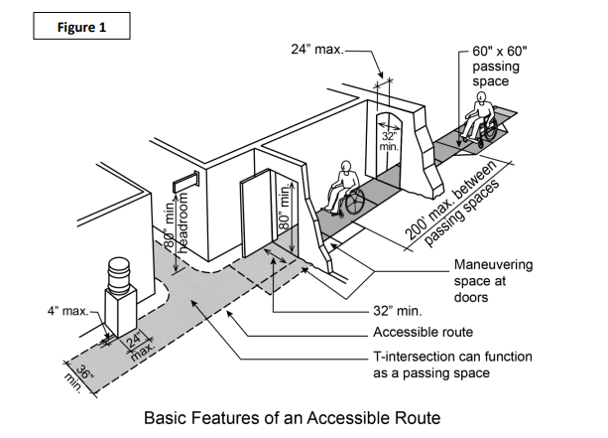
ADA National Network 2015

- Evaluate the Entire Site
  - Carefully assess the entire event space to ensure people with disabilities can move around, access facilities, and participate in activities. Walk the site and identify the most accessible routes. Ideally, everyone should be able to use the same paths and avoid detours.
- Inspect Thoroughly and Use a Checklist
  - Carefully examine all areas of the site to understand its accessibility level. Use a checklist like the one at http://adachecklist.org/checklist.html to identify barriers and potential modifications.

- Modifications to a Site—Removing Barriers
Ways to remove barriers:
- Install ramps.
- Make curb cuts in sidewalks and at entrances.
- Reposition shelves.
- Rearrange tables, chairs, vending machines, display racks, and other furniture.
- Add raised markings on elevator control buttons.
- Install flashing alarm lights.
- Widen doors\install offset hinges to widen doorways.
- Eliminate a turnstile or provide an alternative accessible path.
- Install accessible door hardware.
- Install grab bars in toilet stalls.
- Rearrange toilet partitions to increase maneuvering space.
- Insulate lavatory pipes under sinks to prevent burns.
- Install a raised toilet seat.
- Install a full-length bathroom mirror.
- Reposition the paper towel dispenser in the bathroom.
- Create designated accessible parking spaces.
- Install an accessible paper cup dispenser at an existing inaccessible water
- fountain.
- Remove carpeting that makes maneuvering wheelchairs difficult (i.e. high pile,
- low density carpeting).

Publicity of the event
Many people with disabilities will assume that events will not be accessible. It is important to include statements about access on all publicity and informational material. Statements affirming your commitment to nondiscrimination and accessibility are important. It also may be necessary to provide information on the location of accessible features, such as accessible parking or toilet facilities, or where to obtain other aids or services, such as materials in accessible formats or assistive listening devices.
Here is some simple wording you can include on your website, flyers or other written collateral that makes it clear that your event is accessible and inclusive:
[Organisation] is committed to making [event name] a safe, inclusive and enjoyable event for all. For more information on accessibility services for [event name], visit [URL of accessibility page on event’s website]. For general information about planning for [event name], visit the [organisation/event name]’s official website [URL of official event website].

Accessibility registration forms
Add the below section for an accessibility registration form:
This is an enquiry register for people with disability or additional accessibility requirements wishing to attend [event name]. If you, a friend or a relative have specific accessibility requirements, please complete the form below. If you need assistance completing this form, contact [staff member] on [email address] or [phone number]. If you have hearing or speech considerations, contact accesshub.gov.au and quote our number [phone number]. If you need to contact us through an interpreter, call the Telephone Interpreting Service (TIS) on 13 14 50, and quote our number [phone number].

New Year's Eve Accessibility Registration Form
The Accessible Event Company is dedicated to creating a welcoming and inclusive New Year's Eve celebration for everyone. This registration form is for attendees with disabilities or mobility support needs.
Please complete this form if you or a guest require accessibility accommodations.
If you need assistance completing this form, please contact:
- Access and Inclusion Manager, John Smith: john.smith@accessibleevent.com.au or 02 9123 4567
For assistance with an interpreter, contact:
- Telephone Interpreting Service (TIS): 13 14 50 (request them to contact us on 02 9123 4567)
Please note: Completing this form does not guarantee specific accommodation. We will contact you directly to discuss your needs and explore available options.
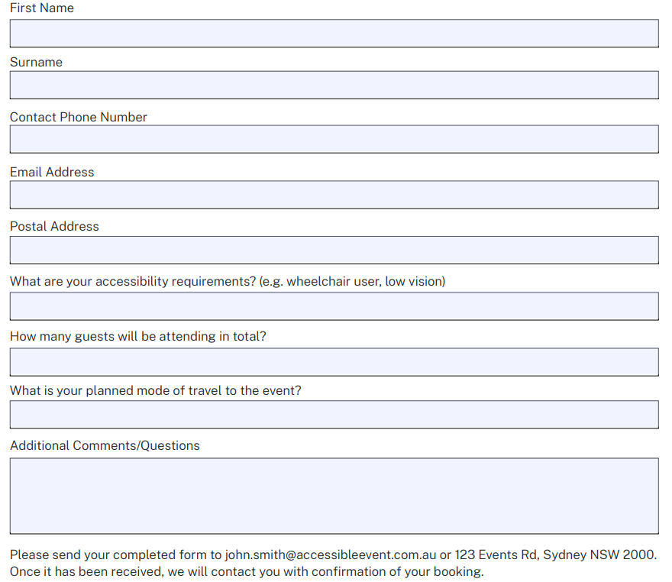

Common tips for Ensuring Digital Accessibility for People with Disabilities
Ensuring digital accessibility is crucial to ensure that everyone, regardless of their abilities, can access and interact with digital content. This includes promotional materials, social media posts, and event information on websites and social media platforms. Here are some common tips specifically tailored to improve accessibility for people with disabilities in the digital space.
Writing Style:
- Plain Language: Use simple and clear language, avoiding jargon and technical terms. Utilize short sentences and bullet points to enhance readability.
- Define Acronyms: Define acronyms the first time they are used to ensure clarity for all users.
Formatting:
- Headings: Employ clear and descriptive headings to organize information effectively and facilitate easy navigation.
- Font Size and Color: Ensure the use of a sufficiently large font size (at least 12 point) and maintain high color contrast between text and background for improved readability.

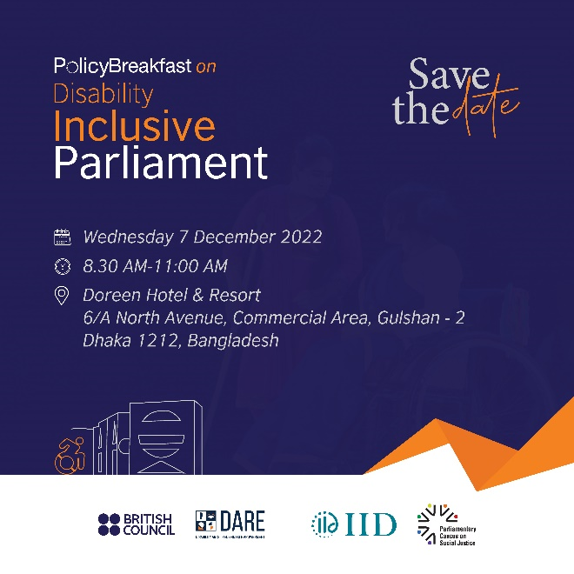
Save the date card designed with digital accessibility in mind, featuring straightforward language, user-friendly navigation, and high text to background contrast

- Alternative Text: Provide descriptive alt text for all images to assist users who rely on screen readers.
Accessibility Features:
- Closed Captions: Include closed captions for videos to ensure access for individuals who are deaf or have hard of hearing.
- Keyboard Navigation: Ensure that your website is navigable using only a keyboard to accommodate users who cannot operate a mouse.
Offer Information in Multiple Formats:
- Easy-to-Read Version: Provide a simplified version of the content using easy-to-understand language and visuals.
- Audio Description: Consider offering audio descriptions of visual content for users who are blind or have low vision.
- Clear Contact Information: Include accessible contact information, such as email or phone, for users to ask questions or request assistance regarding the event.

Usable Type for Printed Information

Pro-accessibility Content Design Tips:

1. Use basic, clear, non-technical language in the active voice.
2. Keep your sentences short—aim for one thought per sentence, under 25 words.
3. Break up instructions with bulleted or numbered lists whenever possible.
4. Opt for a sans-serif font such as Helvetica, Arial, Calibri, or Futura. Avoid mixing up font faces too much.
5. Bold-face type can be used for printed materials with minimal text.
6. Ensure that the type size is at least 16-point, and line spacing is set to 1 ½ or double.
7. Avoid using all caps and underlining text.
8. Left-justify your text for better readability.
9. Use opaque, non-glossy colors and materials for both background and text.

During our initial DARE project event, we recognized the essential need for accessible color palettes to accommodate all attendees, including those are blind or with low vision. In response, we implemented high-contrast color schemes and opted for colorblind-friendly combinations, to enhance readability. This adaptation not only received positive feedback from attendees with disabilities but also set a new standard for our event branding.

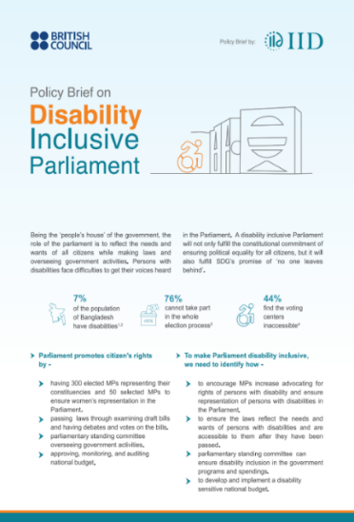
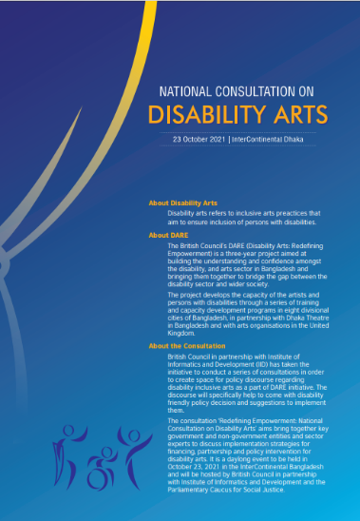

Policy Brief and Event Agenda featuring inclusive color and palette, font, and high text to background contrast.

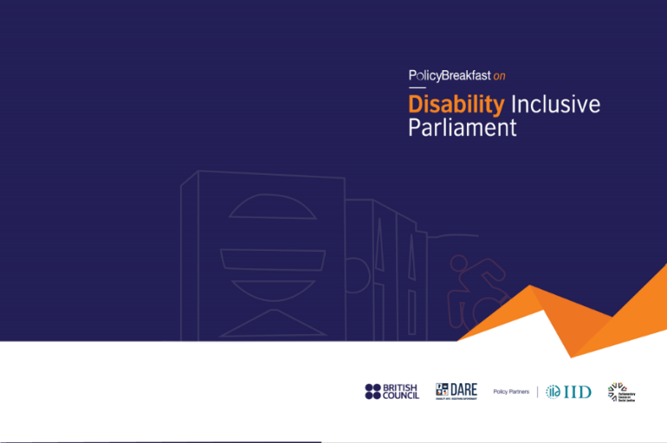
Event Folder featuring accessible design, including an inclusive color palette, font and high text to background contrast.

• In venues catering to a mixed audience with varying visual abilities, combining both braille and standard alphabet, attendees can easily identify the specific document or sign they're encountering. This is especially beneficial in areas with numerous signs or documents displayed, eliminating any ambiguity, and ensuring everyone can quickly access the information they need.

Accessibility Symbols
Publicity materials should include appropriate symbols of accessibility to indicate various features, aids, or services. Internationally recognized accessibility symbols make it easy for those with accessibility requirements to identify facilities that accommodate their requirements. Use them in all signage, including maps, marketing materials, websites, and programs in order to publicize to attendees that your event is accessible. To know details of accessibility symbols, please visit the document at https://www.nsw.gov.au/sites/default/files/2023-07/Toolkit-for-Accessible-and-Inclusive-Events.pdf
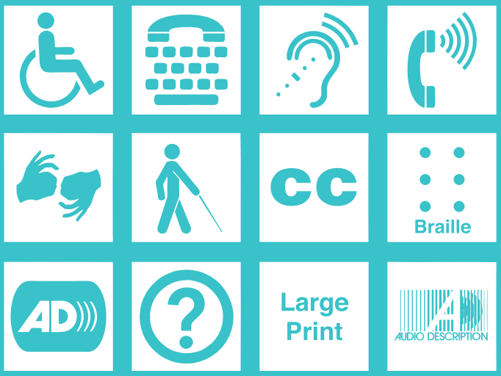
Accessibility Symbols

Getting to the event Site
General Considerations
- Prioritize permanent modifications that comply over temporary solutions.
- Accessibility needs will vary depending on location, transportation options, and event type.
- Focus on providing adequate signage, level changes at curbs with proper slopes, and well-maintained walking surfaces.
- Consider the feasibility of accessibility modifications for different types of organizations (private businesses vs. government entities).

Signage
- Use clear signage with the international accessibility symbol to direct attendees to:
  - Accessible parking spaces
  - Passenger drop-off zones
  - Accessible entrances and gates
- Employ easy-to-read typefaces in a large enough size for visibility from a distance.

Curb Ramps
- Ensure curb ramps (cuts) meet ADA specifications with a slope no steeper than 1:12 (1 inch rise per 12 inches forward).
- Flared sides are permissible at a 1:10 slope if not located in the pedestrian path.
- Consider using portable ramps designed for curbs at temporary events, ensuring they are securely fastened to prevent movement.
- Temporary wooden ramps can also be constructed for specific needs.

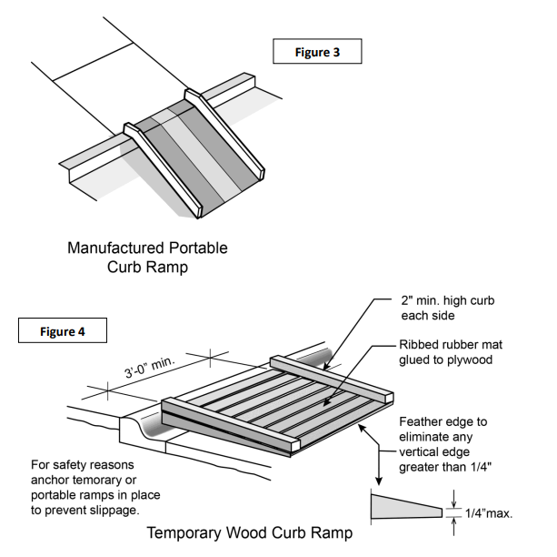
ADA National Network (2015)
Sidewalks
- Address changes in sidewalk surface materials (asphalt to concrete, etc.) to prevent tripping hazards for people using wheelchairs.

Parking
In general, accessible parking spaces should be as close as possible to the main event site and be connected to the entrance by a smooth, level path without curbs or obstructions. And if your event features multiple parking areas, each one should have accessible parking. Check out the ADA National Network’s online guide for a recommendation on how many accessible parking spaces you need to have per total parking spots (and lots of other information about accommodating disabilities with helpful parking options). Note that the ADA National Network’s guide recommends that out of every six accessible spaces, one must be van accessible (at least 132 inches wide)
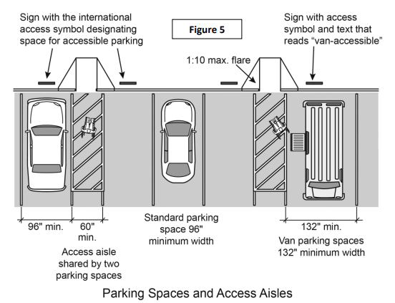

ADA National Network (2015)

Participating in the event

Getting around
Space Requirements for Wheelchairs:
For successful navigation through event spaces, it's crucial to ensure accessible routes for individuals using mobility aids. A minimum space of 30 inches wide by 48 inches long is necessary for parking a wheelchair in a stationary position. Additionally, for a wheelchair to make a 180-degree turn, a circle with a diameter of 60 inches is required. Alternatively, a T-shaped turn can be made at intersections or areas where space may be limited, allowing maneuverability for wheelchair users.
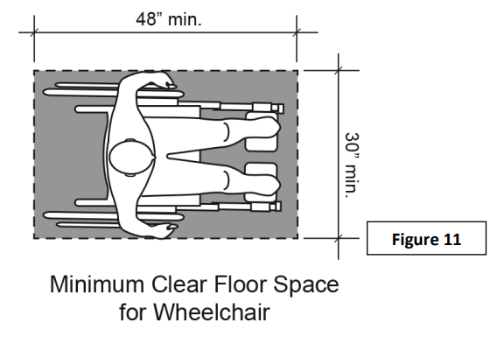
ADA National Network (2015)
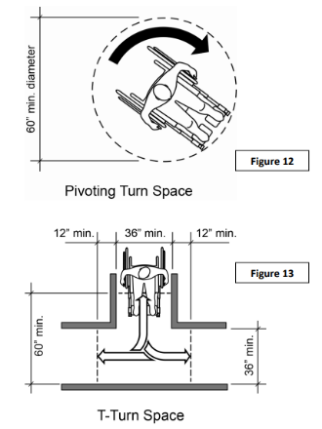
ADA National Network (2015)
Accessible Routes:
Accessible routes should seamlessly connect arrival points, parking areas, and all event exhibits and activities, including amenities like toilets, water coolers, and telephones. These routes should be smooth, level, and wide enough to accommodate wheelchair users without hazards or obstructions. Signage should clearly identify accessible routes, ensuring they align with paths used by the general public whenever possible.
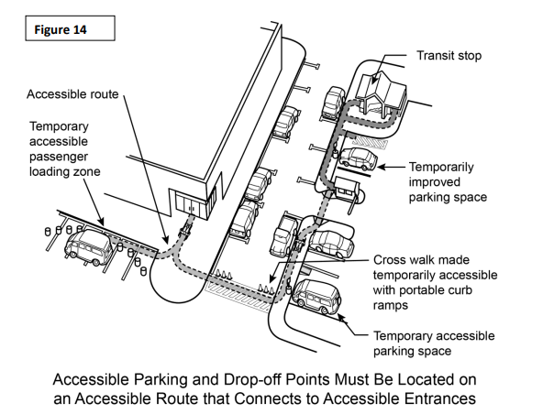
ADA National Network (2015)
Entrances:
Accessible entrances should be free of stairs, with the same entry points preferred for all visitors. Modifications, such as portable ramps or lifts, may be necessary to make entrances accessible. Revolving doors should be avoided, and alternative accessible entrances should be clearly signposted.
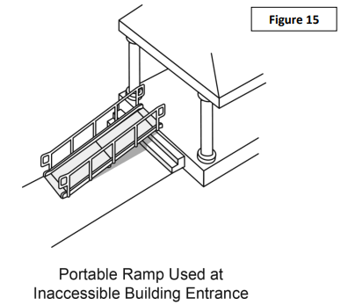
ADA National Network (2015)

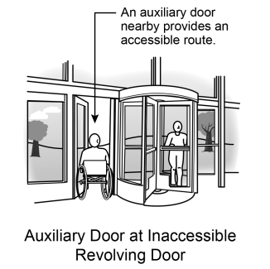
ADA National Network (2015)
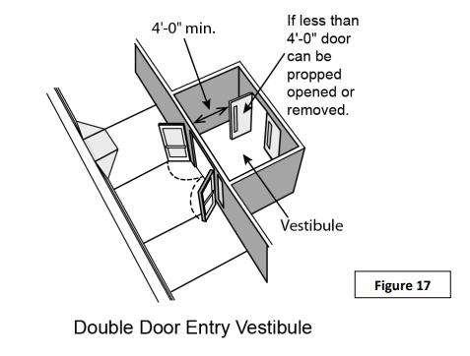
ADA National Network (2015)

Ground and Floor Surfaces:
Surfaces should be stable, firm, and slip-resistant to facilitate easy movement for wheelchair users and those with mobility difficulties. Irregular surfaces like cobblestones should be avoided. Synthetic matting or interlocking rubber tiles can provide stable pathways over unstable ground surfaces. Grates and grilles along accessible routes should have openings no wider than 1/2 inch to prevent accidents.
Doors:
Doors should have a minimum clear opening width of 32 inches, with wider openings preferred for ease of access. Door handles should be replaced with accessible lever or loop types where possible, and excessive door opening force should be avoided. Hazardous protruding objects must be removed or appropriately marked to prevent accidents.

Information and Ticketing:
Information and ticketing areas should be located along accessible routes, with counters or desks at a height of no more than 36 inches. Staff should be knowledgeable about accessibility features and ready to assist visitors with disabilities. Consider providing information in alternative formats, such as large print or audio, for those are blind or with low vision.
Signage:
Signs should be clear, easy to read, and placed consistently throughout the event site. Permanent signs should include tactile characters and Braille, while temporary signs should be added if existing signage is inadequate. Symbols of accessibility should be used to denote accessible routes, parking spaces, entrances, and facilities. Hand-lettered signs should use printed rather than cursive lettering for better readability.

Taking Part in Event

Seating for Event Space
- Provide chairs with and without arms, and bariatric chairs.
- Check line of sight for accessible seating.
- Avoid seats attached to tables.
- Have reserved seating near the front for participants who may be Deaf/Hard of hearing and Blind/Low vision
- If possible, do not place all accessible seating in the same area. For example, integrate accessible seating throughout space, not only front or back of seating options.
- Ensure unobstructed view of ASL Interpreter and Communication Across Real Time Translation (CART) screen/text.
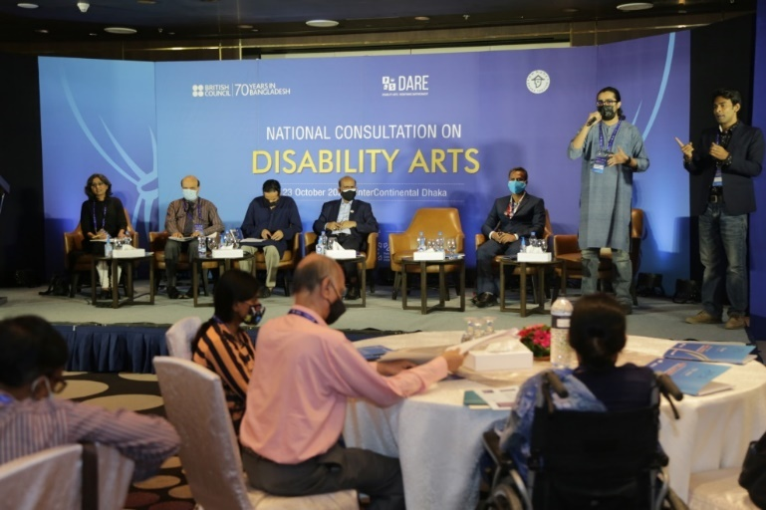

Seating Arrangement near the front of the stage for participants who are deaf/hard of hearing and blind/low vision.

Total Seating Capacity | Required Number of Accessible Spaces
4-25 | 1
26-50 | 2
51-300 | 4
301-500 | 6
Over 500 | 6 (plus 1 additional space for each total seating capacity increase of 100)

Activities and Games
When planning group activities for a meeting or event, it’s crucial to consider the accessibility needs of all participants to prevent unintentional exclusion. Many interactive games require participants to move around or respond to visual cues, such as ice breakers or knowledge testing games. However, these activities can be modified to ensure everyone can participate:
- Modifying a Physical Activity: An example of this is the common ice breaker game ‘Heads and Tails’. Participants are asked to use both hands to indicate their response to a yes/no question by touching their head or tail. If a participant is unable to move in this way, you can select a different physical response. For instance, participants could close or open their eyes, or turn left or right.
- Modifying a Visual Activity: If an activity requires a response to visual information, there are several ways to adapt it for everyone’s participation:
  - Circulate Material Early: Provide visual information to all participants in an accessible form ahead of time. This allows individuals who are blind or have low vision to pre-read the information.
  - Make it Physical: Change the activity to a physical form. Instead of reading material on a whiteboard, ask participants to move from one end of the room to the other, or put their hands on their heads.
  - Make it a Discussion Activity: Change the activity to a discussion activity. Instead of responding to material on a whiteboard, create a question for groups to discuss.
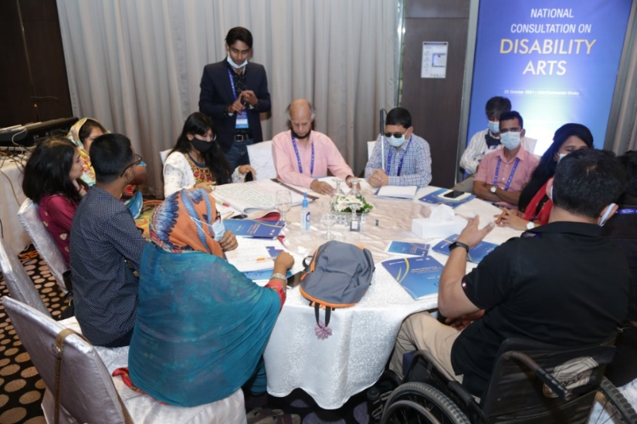
Participants with diverse disabilities fully engaged in group work at the National Consultation on Disability Arts, receiving tailored assistance for effective participation.

Eliminating Communication Barriers for People with Disabilities
Activities requiring communication should be conducted inclusively to facilitate participation by individuals with hearing, vision, or speech disabilities. Here's how to ensure accessibility:
Hearing Disabilities:
People who are deaf or hard of hearing may need written materials, captioned media, assistive listening devices, or sign language interpreter services. Interpreters should be appropriately qualified. Types of interpreters and skill levels vary, and some specialize in certain types of situations, such as interpreting for musical or dramatic performances.
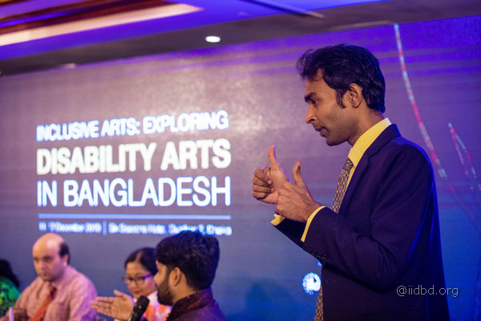
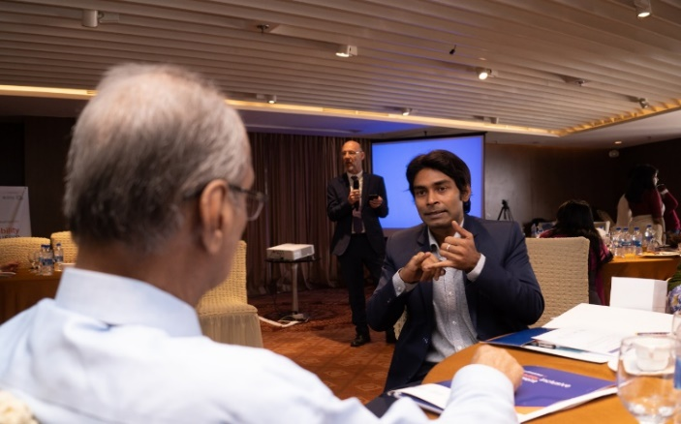
Sign Language Interpreter facilitating communication at DARE events

Vision Disabilities:
People who are blind or have low vision may need aids or services ranging from materials in large print, Braille, or audio format, to staff reading information aloud, describing visual elements (such as images or graphics in a slide show), giving directions, or providing guidance to help locate facilities or activities.

In the 2023 Policy Hackathon, IID prioritized inclusivity by adapting our event to accommodate a blind participant's needs. Direct consultations allowed us to tailor materials in Braille and utilize clear language, steering clear of visual metaphors and minimizing charts. A dedicated assistant ensured full participation in reading, brainstorming, and writing tasks. These efforts not only fostered a sense of belonging but also underscored the value of adaptability and direct engagement with participants' unique needs.
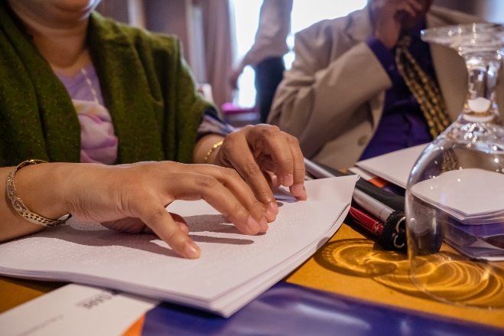
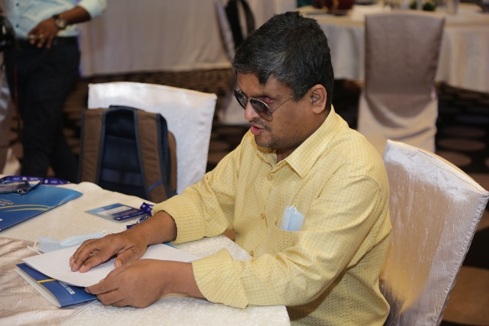

Participants at the National Consultation on Disability Arts, hosted by the IID and British Council, attentively reading Braille document
Participants at the National Consultation on Disability Arts, hosted by the IID and British Council, attentively reading Braille documents

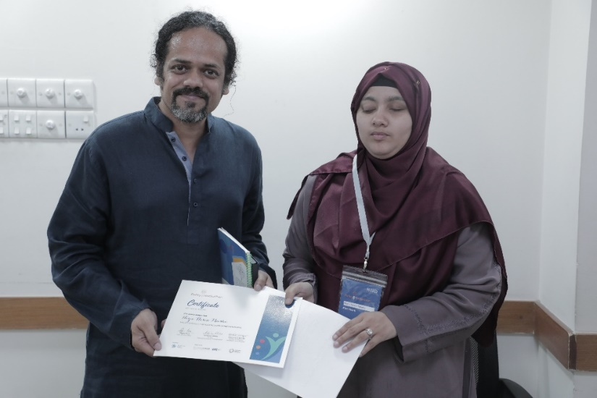
Blind participant receiving certificates in both Braille and standard alphabet at IID’s Policy Hackathon 2023

Cognitive or Developmental Disabilities:
Keep instructions simple, presented in short sentences, and encourage active participation by having participants act after each direction. Patience and willingness to integrate everyone into activities are vital for presenters. Simplified and interactive approaches help individuals with cognitive disabilities engage more effectively.

Inclusive language guidelines
Acceptable terminology in relation to disability is constantly changing – phrases such as ‘handicapped’ and ‘disabled’ which were once standard language can now be considered offensive. These are some general guidelines for inclusive language best practice: Person first as opposed to ‘the Disabled’. For example:
• Person with disability – not disabled person
• Person who is deaf or a person who is hard of hearing – not hearing impaired
• Person who is blind or a person with low vision – not vision impaired
• Person without disability – not able-bodied or non-disabled
• Wheelchair user – not wheelchair bound or confined.
Recognize the person’s individuality:
• Focus on the person rather than the disability. Don’t be afraid to ask!
Focus on accessibility rather than disability:
• Accessibility also includes others with access requirements such as older people, children and carers.
Don’t forget facilities:
• Accessible facility (e.g. Toilet/car space/phone) – not disabled facility. The key rule is – don’t assume all disabilities are obvious

Tips for communication and assistance
We’ve been taught for years that people with disability are ‘special’ or ‘different’, which can make us overly conscious of the risk of offence when interacting with them. But it’s important to remember, just like in the language guidelines, that these are people who just happen to have different access needs. In order to offer the best event experience possible for all attendees, you may wish to include the following tips for communication and assistance in your staff or volunteer training.
Generally:
• Understand that each person with disability is an individual with their own likes and dislikes
• Always focus on the person, not their disability. Always address the person directly, not the other people who may be with them (such as a sign language interpreter or assistant).
• Always ask the person first if they want assistance; do not assume they need it.
• If you are having a conversation that will last more than a few moments with a person using a wheelchair, bend to eye level or pull up a chair.
For a person who may have a learning difficulty, an intellectual disability, dementia or brain injury:
• Address the person directly, listen carefully, speak clearly and check for understanding. Always use clear language without being patronising.
• Allow the person time to ask questions and try not to rush them. Try not to overload the person with information. Make it clear you are there to help if they forget the information.
For a person with low hearing or who is deaf:
• Always face the person so they can read your lips. Try to make sure there are no bright lights behind you that may limit their ability to see your lips.
• Use your normal tone of voice and volume. If possible, move out of areas with lots of background noise.
• Always address your comments directly to a person who is deaf rather than to their interpreter (if a person who is deaf has a sign language interpreter).
• Have a pen and paper on hand to help you communicate with the person if necessary.
For a person with low vision or who is blind:
• Always identify yourself by name. If appropriate, ask for their name so you can address them directly and so that they know you are talking to them and not someone else.
• Ask which side you should be on if a person who is blind asks for assistance to go somewhere and offer your arm so they can hold it just above your elbow.
• Never pat or distract a guide dog or offer it food while it is in harness. It is a working animal under the control of its owner.

Service and Support Facilities

Food and Drink Accessibility at Events
Temporary food service areas, including counters, trailers, and tables, should be designed with accessibility in mind. Here are some key considerations:
- Maintain a maximum height of 36 inches for all service counters. This allows people with mobility limitations to easily reach and interact with staff.
- For food trucks or trailers, consider installing a low folding shelf at an accessible height. This shelf can hold condiments, menus, and other frequently accessed items, making them easier for people using wheelchairs or with limited reach to access.
- Event organizers or vendors can collaborate to offer a centralized condiment table within or near the designated eating area. This eliminates the need for multiple condiment stations scattered throughout the venue and ensures everyone can easily find what they need.
- People with mobility limitations should be able to access all designated dining areas. This includes having an accessible path leading to the area and providing adequate maneuvering space around and underneath tables.
- In scenarios where tables are not readily available near eating areas, consider setting up a few dedicated tables with chairs. This offers a comfortable space for individuals who may have difficulty standing or balancing for extended periods while eating.

Accessible Toilet Facilities for Events
All event restrooms must have:
- At least one accessible toilet stall and a sink that can be used by people with disabilities.
- Clear signage directing users to accessible restrooms in nearby buildings if there are none available on-site.
- Doors that are at least 32 inches wide to allow for wheelchairs and other mobility aids.
- Enough clear floor space to allow for wheelchair turning. This can be either a 5-foot diameter circle or a 3-foot wide T-shaped space.
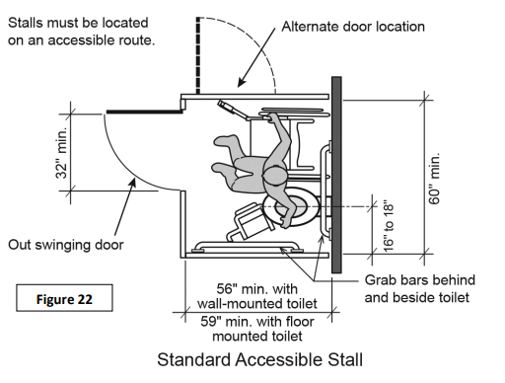
ADA National Network (2015)
For portable toilets at events:
- A minimum of 5% of all portable toilets, or at least one unit, must be accessible to people with disabilities.
- If there are multiple clusters of portable toilets, at least 5% of the units within each cluster should be accessible.
- Accessible portable toilets must have specific features to ensure ease of use, such as:
  - Adequate space for maneuvering a wheelchair inside the unit.
  - Grab bars for support.
  - Toilet paper dispensers that can be reached from a seated position.
  - A level entrance that is accessible from an existing accessible route.
  - Enough space outside the door for wheelchair users to maneuver and open the door.

To know more information on accessibility of toilets at events, please visit the document at https://www.rethinkaccess.com/articles/toilet-room-design

Virtual Venue
Virtual conferences are becoming more and more popular. When planning for a virtual conference, event, or meeting it is important to remember to make it accessible for everyone. The following are things to consider during the planning and implementation of your event.
When organizing a virtual event, consider accessibility and inclusivity at every stage:
Pre-Event Planning:
- Announce accommodation requests in invitations.
- Specify the virtual format in event details for assistive technology preparation.
- Provide a telephone-based option for those without internet access.
- Designate an IT accessibility contact for assistance before, during, and after the event.
- Test audio and video quality; presenters should use headsets for clarity.
- Ensure captions are available for all presentations and videos.
- Consider pre-recording to enable captioning and avoid live technical issues.
- Distribute materials in advance in accessible formats, as screen-shared content may not be accessible to screen reader users.
- For material creation, refer to guidelines for accessible documents (e.g., PowerPoint, Word).
- Arrange for ASL interpreters and CART services for significant or live-streamed events.
- For captioning assistance and pre-recorded events, utilize services like Kaltura for post-event captioning.
Virtual Platform Selection:
- Confirm participant access to the chosen platform.
- Assess any participant costs associated with the platform use.
- Implement security measures against unauthorized access ("virtual bombers").
- Ensure platform compatibility with screen readers and accessible functions (volume control, chat, etc.).
During the Event:
- Offer multiple participation methods (email questions, chat, microphone).
- Allocate time for initial technical troubleshooting.
- Account for technology delays; pause for responses or inputs.
- If recording, provide accessible versions and transcripts.
- Presenters should introduce themselves before speaking.
- Ensure visibility and lighting for presenters and ASL interpreters.
- If using Twitter, compile tweets into an accessible document for broader access.
To know more information on accessibility of virtual events, please visit the document at Accessible Virtual Conferences | SIGACCESS

Feedback Mechanism
Developing a feedback mechanism for making events accessible to persons with disabilities is a crucial step in ensuring continuous improvement and inclusivity.

1. Pre-Event Planning:
- Survey Design: Create a comprehensive survey that covers various aspects of accessibility, such as physical access, communication, transportation, and accommodations. Include questions about the accessibility features you plan to provide (e.g., wheelchair accessibility, sign language interpreters, captioning services, etc.). For Example:
1. Do you require wheelchair-accessible entrances and pathways for navigation during the event?
2. Would you need sign language interpreters for communication accessibility? If yes, please specify the preferred sign language.
3. Are real-time captioning or captioned materials necessary for you to fully participate in the event?
4. Do you require assistive listening devices (ALDs) for improved auditory accessibility?
5. Would you need reserved accessible seating options during the event?
- Accessibility Statement: Include an accessibility statement in event invitations or promotional materials, encouraging attendees to provide feedback on accessibility requirements.
- Alternative Formats: Ensure the survey is available in alternative formats, such as large print, braille, or accessible digital formats, to accommodate diverse needs.
2. During the Event:
- Feedback Stations: Set up designated feedback stations equipped with accessible devices (e.g., tablets with screen readers) where attendees can provide real-time feedback.
3. Post-Event Follow-Up:
- Online Surveys: Send out post-event surveys via email or accessible online platforms, allowing attendees to provide detailed feedback at their convenience. The questions could include:
- Were the venue and facilities physically accessible to you?
- Were materials provided in accessible formats (e.g., braille, large print, electronic)?
- Did you receive adequate support or assistance during the event?
- Were communication methods (verbal, written, sign language) suitable for your needs?
- What additional accommodations would you suggest for future events?
- Do you have any other comments or suggestions for improving the accessibility of our events?
- Focus Groups: Organize focus groups comprising persons with disabilities to delve deeper into specific accessibility issues and gather qualitative feedback. Questions could include:
- What specific barriers did you encounter during the event?
- What accommodations or adjustments would have enhanced your experience?
- Do you have any recommendations for making future events more accessible?

4. Feedback Analysis and Action:
- Data Analysis: Collate and analyze feedback data to identify common themes, challenges, and areas for improvement regarding accessibility.
- Prioritization: Prioritize actionable feedback based on severity and frequency of issues reported by attendees with disabilities.
- Action Plan: Develop a comprehensive action plan outlining steps to address identified accessibility gaps, including timelines and responsible parties.
- Communication: Communicate transparently with attendees about the actions taken in response to their feedback, demonstrating a commitment to continuous improvement.
- Regular Reviews: Conduct periodic reviews of accessibility measures and feedback mechanisms to ensure ongoing relevance and effectiveness.
6.Public Reporting
- Compile feedback received and actions taken into an accessibility report.
- Make this report publicly available on event websites or through other channels to foster transparency and accountability

Resources
- ADA National Network. (2015). A Planning Guide for Making Temporary Events Accessible to People with Disabilities. Retrieved from https://adata.org/publication/temporary-events-guide
- NSW Government. (2023). Toolkit for Accessible and Inclusive Events. Retrieved from Toolkit-for-Accessible-and-Inclusive-Events.pdf (nsw.gov.au)
- Unicef. (2022). TOOLKIT ON ACCESSIBILITY. Retrieved from https://accessibilitytoolkit.unicef.org/media/656/file/PDF%20-%20Section%20F:%20Organization%20of%20Accessible%20Events.pdf
- The University of Kansas. Best Practice Guidelines for Planning an Accessible Event. Retrieved from https://kualerts.com/maintenance/eventVenueConsiderations
- Meetings & Events Australia. (2019). ACCESSIBLE EVENTS: A Guide for Meeting and Event Organizers. Retrieved from accessible_events_guide.pdf (meetingsevents.com.au)
- Women with Disabilities Development Foundation (WDDF). PERSONS WITH DISABILITIES RIGHTS AND PROTECTION ACT IN BANGLADESH USER-FRIENDLY BOOKLET. Retrieved from Persons with Disabilities Rights And Protection Act 2013 User-Friendly Booklet (ilo.org)
- United Nations. Convention on the Rights of Persons with Disabilities – Articles. Retrieved from Convention on the Rights of Persons with Disabilities – Articles | United Nations Enable

Checklist for Inclusivity and Accessibility

A. Persons with Physical Impairment

Ensure Physical Accessibility:
[ ] Wheelchair accessibility for entrances, exits, restrooms, and seating areas.
[ ] Provide assistive devices like ramps, elevators, and handrails.
[] Reserve designated seating areas for easy access and clear lines of sight.

Communication:
[ ] Treat individuals with respect and avoid making assumptions.
[ ] Ask about preferred communication methods.
[ ] Be patient, attentive, and maintain eye contact.
[ ] Use inclusive language and personfirst terminology.
[ ] Avoid interrupting and allow sufficient time for communication.

Assistive Technology and Resources:
[ ] Familiarize yourself with common assistive devices.
[ ] Provide necessary accommodations like captions, transcripts, or communication boards.
[ ] Train staff and volunteers on inclusive practices and assistive technologies.

Respect Personal Boundaries and Preferences:
[ ] Seek consent before providing physical assistance.
[ ] Follow individual preferences and instructions.
[ ] Be open to feedback and make necessary adjustments.

Icebreaker/Energizer/Group Activities:
[ ] Choose activities that do not require heavy physical movement or exertion.
[ ] Provide alternative communication options.

Facilities and Accessibility:
[ ] Ensure venues have wheelchair accessibility with ramps and wide doors.
[ ] Create a stepfree environment throughout the venue.
[ ] Minimize walking distances between session venues, dormitories, and facilities.
[ ] Ensure a nonslip floor in the venue.
[ ] Provide clear signage for elevators, dormitories, dining rooms, and accessible toilets.
[ ] Organize participants/guests into small groups during mealtime to avoid long queues.

B. Persons who are Blind/Low Vision

Ensure Physical Accessibility:
[ ] Provide accessible pathways and tactile indicators.
[ ] Install handrails and barriers.
[ ] Reserve designated seating areas with unobstructed views.

Communication:
[ ] Treat individuals with respect and inclusivity.
[ ] Inquire about preferred communication methods.
[ ] Use clear and descriptive language.
[ ] Provide detailed explanations.

Assistive Technology and Resources:
[ ] Familiarize yourself with assistive technologies.
[ ] Provide necessary accommodations.
[ ] Offer braille print documents.
[ ] Read out materials verbally.

Facilities and Accessibility:
[ ] Explain the layout and design of the session venue.
[ ] Describe the layout of residential rooms.
[ ] Ensure braille elevator buttons and accessible directional signs.

C. Persons who are Deaf/Hard of hearing

Ensure Physical Accessibility:
[ ] Provide accessible pathways and visual indicators.

Communication:
[ ] Treat individuals with respect and inclusivity.
[ ] Inquire about preferred communication methods.
[ ] Utilize sign language interpreters.
[ ] Provide qualified sign language interpreters.
[ ] Learn basic sign language phrases.
[ ] Allow ample time for communication.

Assistive Technology and Resources:
[ ] Provide written materials and visual aids.
[ ] Utilize assistive listening devices.

Virtual Workshops:
[ ] Ensure clear visibility of sign language interpreters.
[ ] Use captioning and transcription services.

Collaboration and Group Activities:
[ ] Promote effective communication strategies.
[ ] Foster a supportive atmosphere.
[ ] Adapt activities as needed.

D. Persons with Speech Impairment

Communication:
[ ] Treat individuals with respect and inclusivity.
[ ] Use personfirst language.
[ ] Be patient and attentive.
[ ] Use alternative communication methods.

Assistive Technology and Resources:
[ ] Familiarize yourself with augmentative and alternative communication (AAC) devices.
[ ] Provide necessary accommodations.

Inclusive Group Activities:
[ ] Foster a supportive and inclusive environment.
[ ] Provide alternative ways to contribute.
[ ] Ensure equal opportunities.

Training and Sensitization:
[ ] Provide training on inclusive practices.
[ ] Sensitize participants.

Virtual Meetings:
[ ] Ensure clear visibility of sign language interpreters.
[ ] Use captioning and transcription services.

